China Persona

Persona A: Offline Full-Price Affordable Luxury Bag Seeker
【Core Definition】
A young female around 27 years old who prefers purchasing affordable luxury handbags at full-price offline stores, with a strong preference for classic styles and new collections.
Quantitative Attributes (Radar Scores & Average)
- Total user coverage: approximately 6,395 users
- Average Order Value Score: 93.3 / 100 (Avg: ¥2549.61)
- Discount Sensitivity: 53.3 / 100
- Offline Preference: 90.0 / 100
- Social Dependency: 60.0 / 100
- Return Tendency: 53.3 / 100 (Avg returns: 0.029)
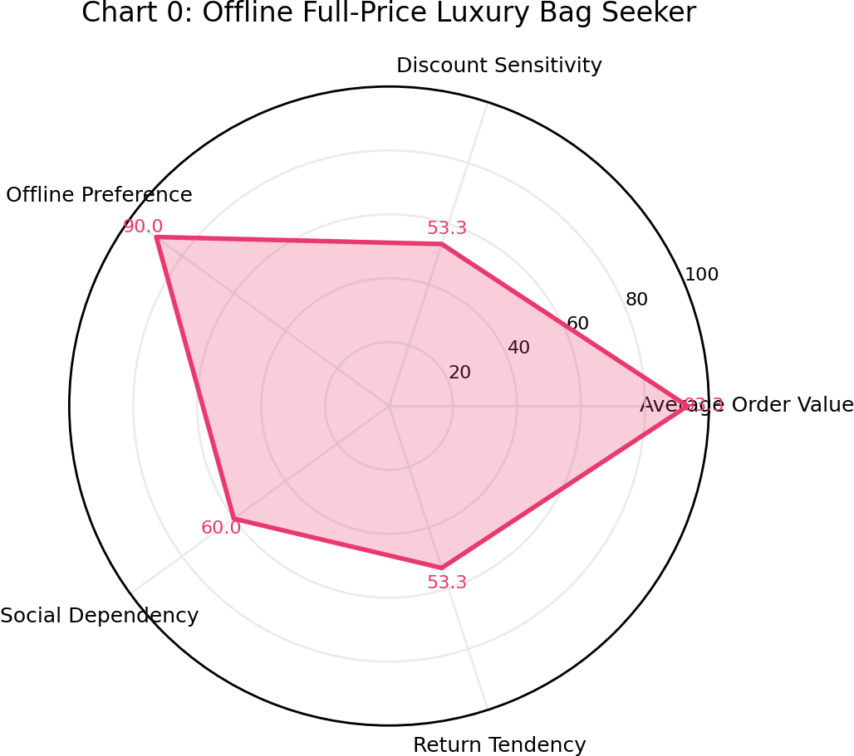
Insight Analysis
1. Profile Characteristics
She is a 27-year-old female living in a new tier-1 city such as Wuhan. She is a white-collar worker with around 3 years of experience, having a stable monthly disposable income. She values outfit quality and is surrounded by a social circle that consumes affordable luxury items. She has her own fashion judgment and does not blindly follow influencer trends.
2. Shopping Behavior
She rarely binds membership through platforms like Tmall, Douyin, or JD, and seldom follows brand public accounts. Her primary shopping channel is offline full-price retail stores. Occasionally, she learns about brand updates via mini-program links shared by friends.
Her main purchase category is women's handbags, occasionally accompanied by small leather goods and accessories. Her average spending per purchase ranges between ¥2000–¥5000. She is willing to spend generously on classic or new designs she likes, has almost no return behavior, and occasionally receives gifts from stores.
3. Psychological Motivation
She chooses offline full-price stores mainly because she can try on bags in person and evaluate materials firsthand, avoiding the risk of counterfeit products from e-commerce channels, thus feeling more confident in her purchase.
She also believes affordable luxury handbags are essential items to enhance outfit quality. A well-designed and durable bag can be used for years, making it a reasonable reward for her hard work. She avoids binding third-party memberships to reduce marketing interruptions, prefers to purchase only when necessary, and highly values autonomy in shopping decisions.
Marketing Recommendations
Offline stores should highlight popular classic bag series such as Tabby, Brooklyn, and Juliet, paired with small leather goods for scenario display.
Provide exclusive in-store services such as free engraving and one-year free leather care to enhance the shopping experience.
Since she often enters the brand via friend-shared mini-programs, brands can launch referral campaigns such as “¥50 in-store coupon + gift” to encourage customer acquisition.
Avoid frequent marketing messages; instead, notify her selectively (e.g., new product launches with exclusive try-on offers).
Avoid heavy discount promotions to protect brand value perception. At the end of seasons, offer exclusive benefits such as limited-time discounts on classic styles or priority access to new product pre-orders.

Persona B: Socially-Influenced Affordable Luxury Bag Experimenter
【Core Definition】
A young urban individual around 26 years old who encounters brands through social sharing and prefers purchasing affordable luxury handbags at full price for personal use or gifting.
Quantitative Attributes (Radar Scores & Average)
- Total user coverage: approximately 5,811 users
- Average Order Value Score: 100.0 / 100 (Avg: ¥2672.85)
- Discount Sensitivity: 46.7 / 100
- Offline Preference: 73.3 / 100
- Social Dependency: 53.3 / 100
- Return Tendency: 60.0 / 100 (Avg returns: 0.03)
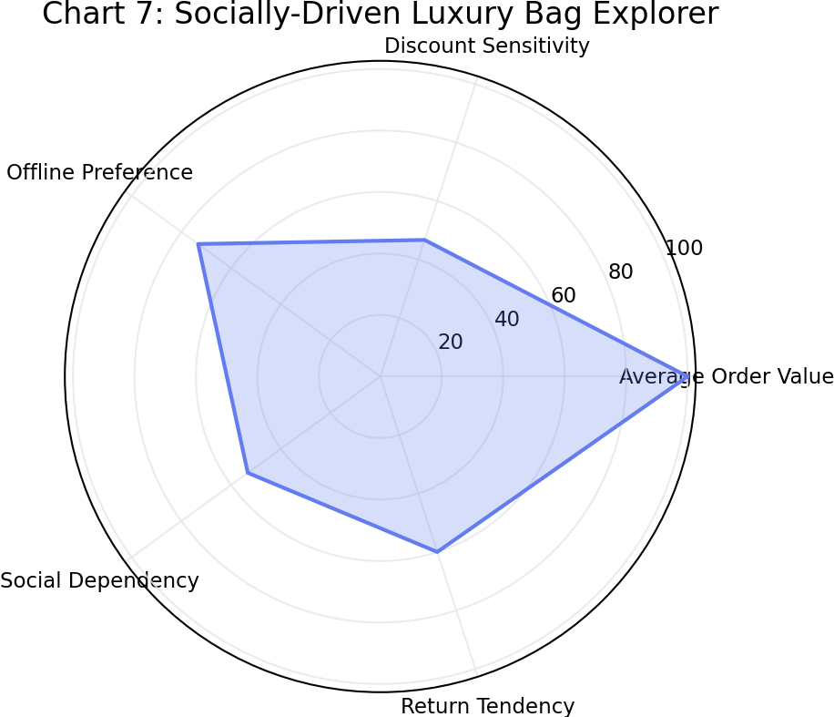
Insight Analysis
1. Profile Characteristics
He is a 26-year-old male professional living in a new tier-1 city such as Suzhou. He is in a stable relationship and earns an above-average income. He pays attention to affordable luxury and fashion content, is willing to pay a reasonable premium for desirable products or gifts for his partner, and values quality of life.
2. Shopping Behavior
He only purchases through official full-price brand channels, never considering outlet or discount channels, and does not bind membership through e-commerce platforms such as Tmall, JD, or Douyin.
He most commonly accesses brand mini-programs through links shared by friends. His primary purchases are popular women’s handbags, occasionally buying men's accessories like belts or wallets.
His average order value is between ¥3000–¥5000, and his annual spending on the brand is typically no less than ¥2000, with very low return rates.
3. Psychological Motivation
His main motivation is gifting, especially during occasions such as Valentine’s Day or anniversaries, where he selects popular handbag styles as gifts for his girlfriend.
He believes full-price products offer better quality assurance and express sincerity more effectively. He avoids discounted products due to concerns about quality or outdated styles.
Purchasing through friend-shared mini-programs provides a sense of reliability and convenience.
Marketing Recommendations
Brands should target this group with curated gifting bundles for key occasions, such as pairing Tabby or Willow bags with scarves or mini charms.
Offer value-added services such as handwritten cards or customized premium gift boxes instead of focusing on discounts.
Marketing should prioritize WeChat social channels, leveraging shareable mini-program cards.
Before key gifting occasions (e.g., Valentine’s Day, 520, Qixi Festival), push targeted content such as gifting guides to young male users.
Introduce referral incentives where both sender and recipient receive exclusive gifts.

